 | YEAR 12 MATHEMATICS SPECIALIST  SEMESTER ONE 2017  QUESTIONS OF REVIEW 1: Polynomials & Polars

Name: _______________________

Friday 17^{h} February Time: 30 minutes Mark /30

Calculator free.

[4 marks – 2 each]
Convert:

to polars

to rectangular co-ordinates

[4 marks – 1 each]
For , evaluate:

, with a real denominator

[6 marks – 1, 2, 1, 1, 1]
If and , determine, in cis form:

[8 marks – 1, 1, 1, 1, 1, 2, 1]
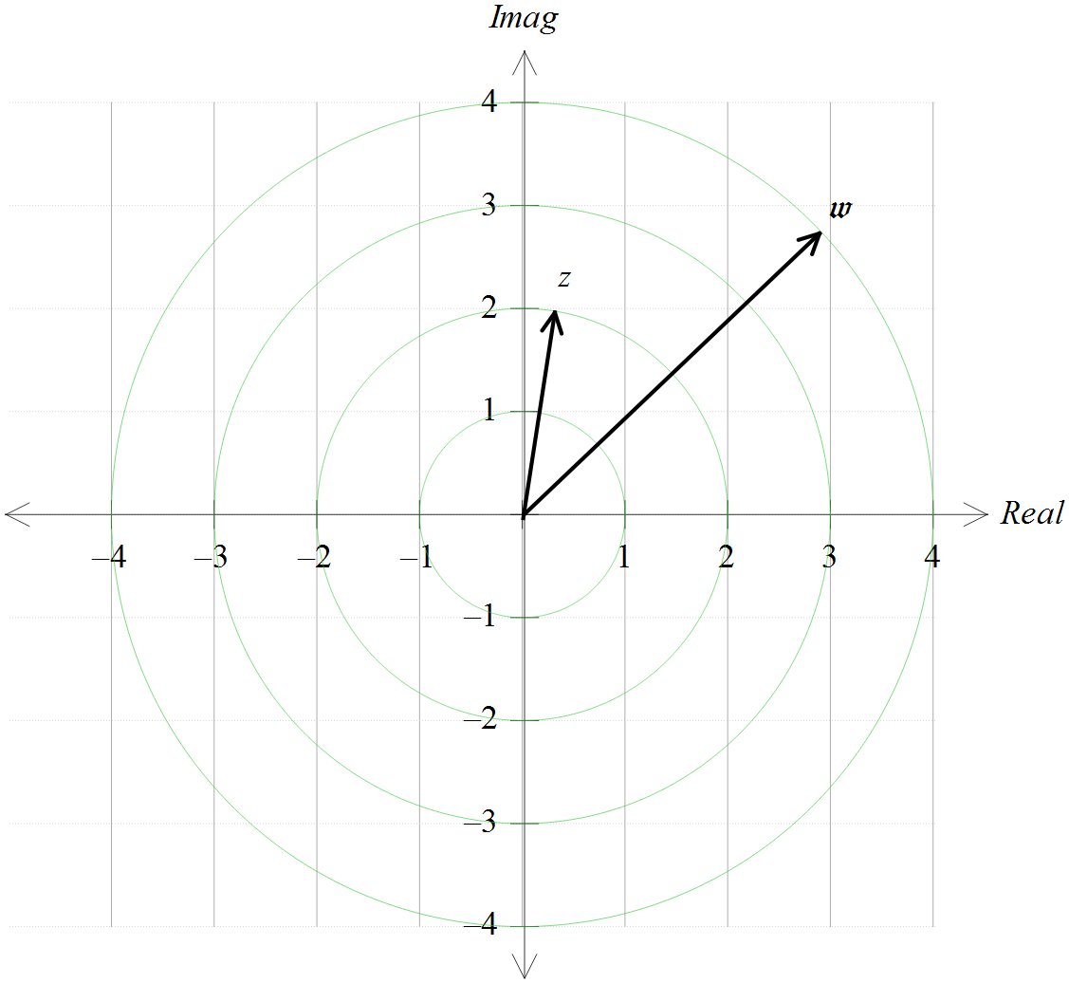Two complex numbers, and are shown on the Argand diagram. Add each of these to this diagram:

[8 marks – 1, 1, 1, 2, 3]
For

express in terms of a

determine the remainder, in terms of a, when is divided by

evaluate a if:

write a polynomial expression for

find all the roots of

